**High-End vs. Mid-Range Android Smartphones**

**Do High End phones really offer something extraordinary and are they really value for the money?**

So, this is a usual quarrel between the youngsters these days that whose smartphone is better.

Some have better camera, some better processor and some are just stylish enough to argue for. This vast list of specifications never ends. It is quiet captivating that how in the past few years smartphones changed the communication industry around us. There has been an exponential growth in terms of size, design, speed, software and camera since the first smartphone came out. For the record, most of the smartphone manufacturers are announcing their new flagship phones roughly every three months. I remember when Samsung launched the Galaxy Note back in 2011, no one would have thought that the 5 inch form factor would be more than a regular stuff today.

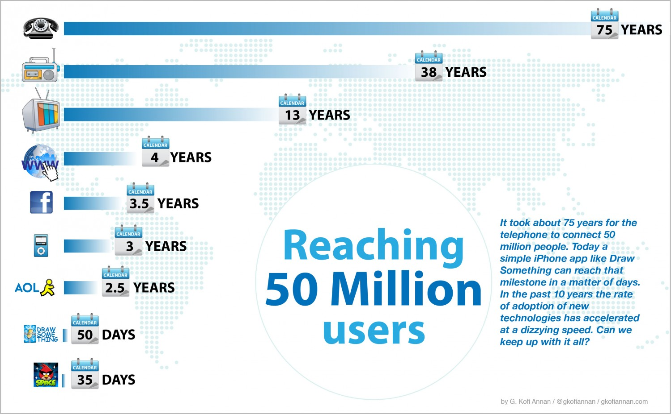

But, are these changes really worth?

I mean , on one side there’s a huge range of smartphones under 20k which can offer almost all the normal specifications and can run whatever thrown at them and on the other hand there is whole other range of high end fascinating smartphones with a price tag of above 50k . The point being made here is that are these phones really worth so much. I agree that these high end phones have a much better built factor, have a premium and classy touch ,but as far as the performance is concerned, there no such significant difference between the two sets of phone. Clearly there is some exclusivity in all the brands such as HTC’s Gesture controls, Sony’s camera controls, Samsung Galaxy Note’s Pen controls, etc. But these controls do not come handy all the time. The conclusion is that these are not so charming features to make these phones a must buy.

On the other hand there’s the Chinese giant Xiaomi which has been producing world class mid- range budget phones. Also some of these products are so designed that these just work perfect with the components they are made with, resulting in a smooth experience.

Also, people at least in India have this mentality to have the best with them. This results in people buying the high end phones. Hence, they do not buy according to their needs but just for showing it off. For instance, if a smartphone is specifically designed for the business class, how can possibly a 16 year old be benefited by that phone!

It is evident that high priced are better in every aspect in comparison to the mid-ranged phones, but we all can be clever enough to carefully analyze and invest according to our needs. Also, Micromax is the highest selling smartphone in India because it concentrated on reaching the mass with its mid ranged phones.

Technology is all about changes and innovations which invests in our better future. Mobile phones have now become an integral part of our lives. Hence this is one of the most rapid growing industries in the world.